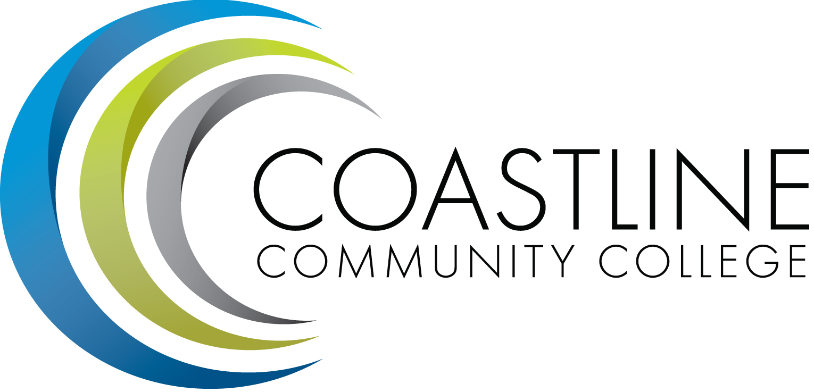
Planning, Institutional Effectiveness, and Accreditation Committee (PIEAC)
November 16, 2016
1:30 p.m. to 3:30 p.m.
Fourth Floor Conference Room

- CALL TO ORDER
  - Roll Call
  - Welcome
  - Adoption of Agenda
  - Approval of Minutes: October 19, 2016

- REPORTS
2.1 Accreditation (new standards) V. Rodriguez & D. Pittaway
2.2 Instruction and Student Services Wing Priorities V. Rodriguez & R. Miyashiro

3. STANDING REPORTS
3.1 Accreditation V. Rodriguez
3.2 Budget Committee R. Lockwood
3.3 Program Review A. Zentner
3.4 Grants D. Aistrich
3.5 President’s Report L. Adrian
3.6 Wing Reports V. Rodriguez, C. Nguyen, R. Miyashiro
3.7 College Council V. Rodriguez
3.8 Facilities C. Nguyen
3.9 MECTBD J. Groot
3.10 Student Success Committee B. Keeler
3.11 Institutional Effectiveness Grant A. Zentner
3.12 College Promise L. Adrian
3.13 Other Committees Committee

4. ANNOUNCEMENTS (1-2 minutes per)

5. ADJOURNMENT

